Craigs Aspiring Art Prize 2018
Judges notes – by Aimee Ralfini

Craigs Investment Partners Prize of $10,000.00
Liam Gerrard – Gallows Hymn.
This arresting and haunting work invites us to participate in its story.
Expertly crafted in charcoal, the elements portrayed are easily recognisable to all –
a close up presentation of cottage fencing, flora and fauna. With stark and contrasting textures and shapes, Gallows Hymn creates an interweave of information which nods to a gothic past, present ideals around colloquial attainability, and some unknown future experience.
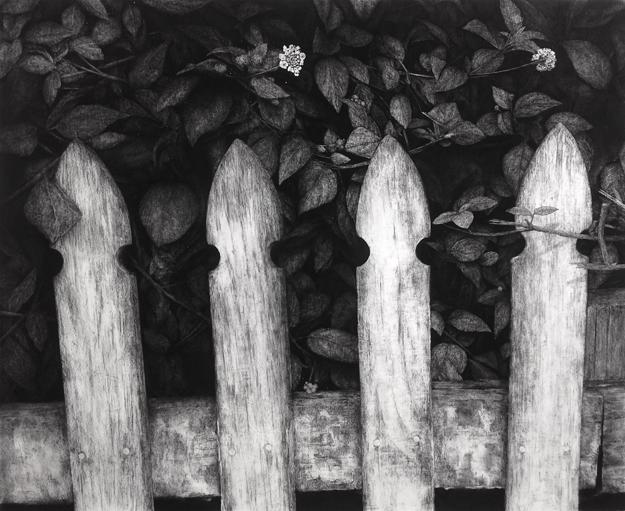

Craigs investment Partners Runner Up
Amy Baker – Had enough?
This instantly recognisable portrait stood out like a Mona Lisa amidst a sea of farm animals and a wide spread of southern landscape paintings.
Issuing a commanding expression of thoughtful pause, this artwork offers a moment of inspection never afforded by the subject in real life.
The work is loaded with metaphorical dualities between the subject, himself, and a land, which in governing collalition he represents.
Scottish wool and Chinese silk are used in reference to the subject’s heritage. The embroidered lines of this figure follow contours like some topographical landscape, creating a surface terrain full of stitched tension between the different fibres used.
The subjects grey hair is made from dog fur, bound by human hair and silver threads of harakeke flax from the artists garden, its texture licks the navy blue Thai-silk background – as central tussock does the sky.
Humorous, sensitive and crafted with astounding skill, this potent work resonates in the mind well beyond veiwing.
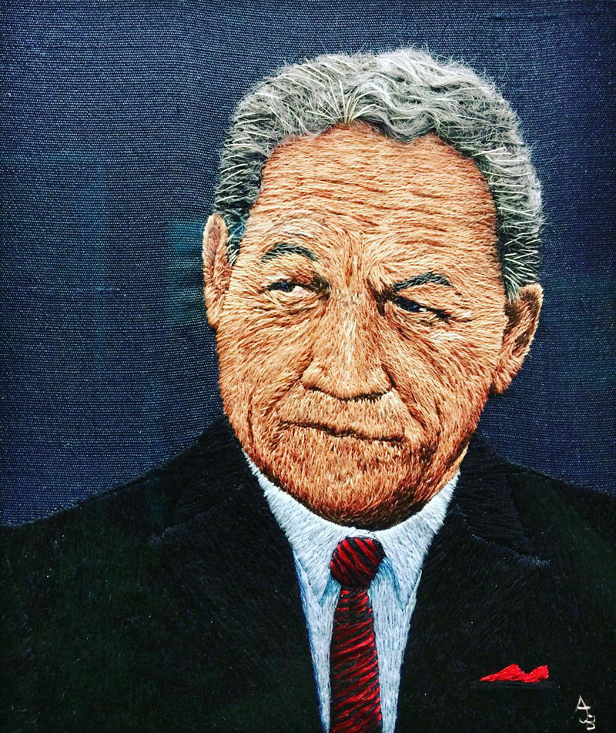

The Landscape artist. All three of our top works fitted within the landscape context.
Brian Stewart – Wilson’s Lab Revisited
A captivating painting of an interior scene from Scott’s Cape Evans Hut in Antarctica, this work presents the landscape from within, evoking the space, stillness and isolation of the Antartic environment in which it is situated. Through a limited, translucent colour pallette, the artists use of light dances beneath the eyes in the same way a vast and bright exterior can.
Structurally the artwork opens a plethora of juxtapositions from within a single scene. These refer across a tradition of religious art history, such as the symbolism of triptychs, light as purity and story telling via placement of objects. For example, we see three snow-filled windows flooding the room in white light, adding an element of the divine to the setting. However, such light only illuminates an arrangement of scientific instruments. The implication is that it is the science, the technical, the non-spiritiual seperating the viewer from the full Antartic experience.
Once drawn in, the instruments direct our eye back out to the landscape, hypnotically creating a circular trap (around and around it goes) bringing the outside in then drawing us out again.
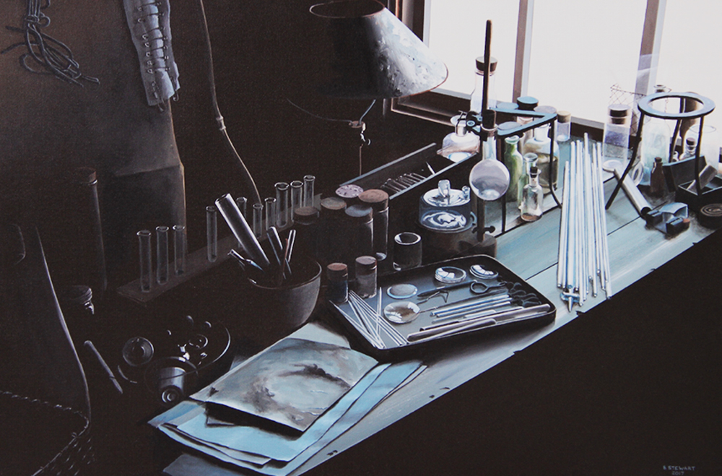

The prize for the best work under one thousand dollars
Becky Cameron – Journey’s On and Off the Map.
This study of a mountainscape is reclaimed over the contours of a topographical map. The artist’s use of colour and form is expressed by a variation of seductive lines, scribbles, dashed marks and washes of colour. Beautifully composed, it’s superb use of colour in conjunction with a fluid technique, creates a Central landscape as vibrant as it is majestic.
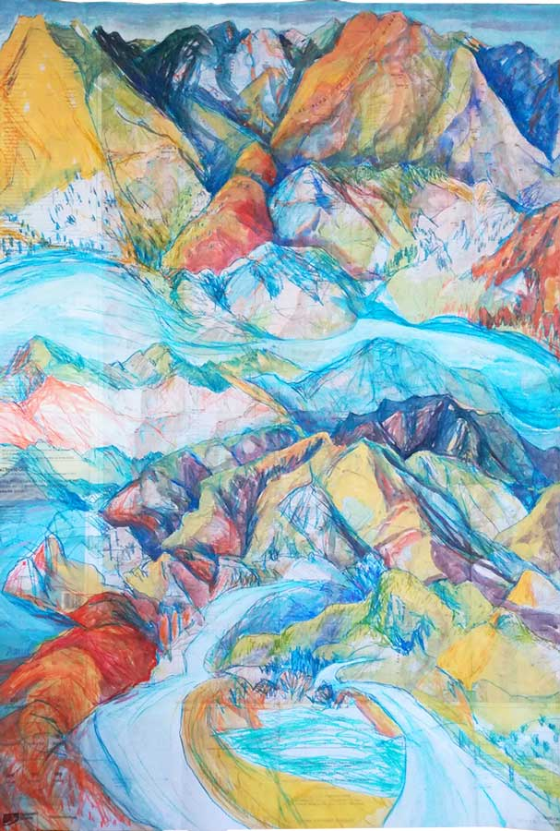
Note: It is worth noting that all four winning works used humble media. The winning work used charcoal – alone – to convey a powerful and inclusive story. The use of highly toxic and non-sustainable materials by an artist in today’s environment, not only degrades the health of the planet, but brings the intelligence of the artmaker and her/his connection to the world supporting all of us into question.
It would be inspiring to see ALL artists making a transition toward more sustainable practice.

